**Chapter 1**

**Introduction**

* 1. **Problem Statement**

Due to the changing technology, it is essential for the agricultural sector to adapt to the changes adequately. Hence it becomes a necessity to bridge the gap between the IT sector and the agricultural sector. Through this project, these aspects are examined and made possible.

* 1. **Objectives**

Aim is to create a one-step portal for informational retrieval and to buy various farming related products online. This is made possible through the simple click of a button.

The following objectives are achieved:

1. A farmer can create an account and get information about the various crops and fertilizers available in the market.
2. A farmer can buy various agricultural products
3. The admin can add new products and new crops/fertilizers.
   1. **Scope**

The scope of this project is to ensure the best use of computer based management system for reducing the efforts of farmers to access information about crops and fertilizers; it also provides the farmers an easy access to buy various agriculture related products. It expands the reach of the agriculture sector.

**Chapter 2**

**Literature Survey**

**2.1 Traditional File System**

In the early days of computing data management and storage was a very new concept for organizations. The traditional approach to data handling offered a lot of the convenience of the manual approach to business processes (e.g. handwritten invoices and account statements, etc.) as well as the benefits of storing data electronically.

The traditional approach usually consisted of custom built a data processing and computer information systems tailored for a specific business functions. An accounting department would have their own information system tailor to their needs, where the sales department would have an entire separate system for their needs.

Initially, these separate systems were very simple to set up as the mostly mirrored the business process that departments had been doing for years but allows them to do things faster with less work. However, once our systems were in use for so long, that became very difficult for individual departments to manage and rely on their data because there was no reliable system in place to enforce the data standards for management.

Separate information systems for each business function also lead to the conflicts of interest within the company. These separations of data also lead to unnecessary redundancy and high rate of unreliable and inconsistent data.

**2.2 Pros and Cons of the Traditional Approach**

**Pros**

1. **Simple**

* Matched existing business processes and functions.
* Companies were not as interested in funding complicated Information Systems.

1. **Initially low cost**

* Early computing was not viewed as beneficial for large funding.
* Systems are designed to be cheap in order to save on cost.

**Cons**

1. **Separated ownership**

* Business functions had a high sense of data ownership.
* Departments unwilling to share data for fear of minimising their superiority.

1. **Unmanaged redundancy**

* Multiple instances of the same data appeared throughout various files, systems and databases.
* Information updated in one place was not replicated to the other locations.
* Disk space was very expensive and redundancy had a big impact on storage.

1. **Data inconsistency**

* Redundant data stored in various locations was usually never stored the same way.
* Formatting was not centrally managed.

1. **High cost in the long run**

* Hiring data processes for each department was very expensive and each position of typically working on the same thing just for a different area.

**2.3 Downfall of Traditional Management System**

Conceived in a relatively centralized era when software was developed in static environment, legacy database architectures failed to support an increasingly mobile world when applications are accessed anytime, anywhere.

However , legacy database Technologies fall short in serving the needs of today's distributed and cloud environment for the following reasons:

* Inadequate failure capabilities
* Latency issues
* Insufficient provisions during peak demands
* Lack of high availability at all times
* Increasing operational costs

For all of these reasons, traditional databases are unable to deliver results in a rapidly growing environment where the workload is geographically distributed across heterogeneous data centres. Upgrading two or more distributed data model is costly and complicated and your DBAs can't just sit back and give up on this situation. Hence due to this various reasons, the downfall of the traditional system was inevitable.

**2.4 Introduction to the database management system**

A Database Management System (DBMS) refers to the technology for creating and managing databases. Basically, a DBMS is a software tool to organise (create, retrieve, update and manage) data in the database.

The main aim of DBMS is to supply a way to store and retrieve database information that is both convenient and efficient. By data, we mean known facts that can be recorded and that have embedded meaning. Normally people use software such as DBASE IV or V, Microsoft ACCESS or EXCEL to store data in the form of database. A datum is a unit of data.

Database systems are meant to handle large collection of information. Management of data involves both defining structures for storage of Information and providing mechanism that can do the manipulation of the store information. Moreover, the database systems must ensure the safety of the information stored,despite systems crashes or attempts at unauthorised access.

**2.5 Indicative areas for the use of DBMS**

* Airlines: reservations, schedules etc.
* Telecom: calls made, customer details, network usage etc.
* Universities: registration, results, grade etc.
* Sales: products, purchases, customers etc.
* Banking: all transactions etc.

**2.6 Advantages of DBMS**

A Database Management System has many advantages over the traditional file system used in the earlier days, such as:

* **Data Independence**: Application programs should be as free or independent as possible from details of data representation and storage device can supply and abstract of the date of insulating application code from such facts.
* **Inefficient Data Access**: DBMS utilizes the mixture of sophisticated concepts and techniques for storing and retrieving data competently and this feature becomes important in cases where the data is stored on external storage devices.
* **Data Administration**: When several users share the data, integrating the administration of data can offer major implements. Experienced professional understand the nature of data being managed and can be responsible for organizing the data representation to reduce redundancy and make the data to retrieve efficiently.

**Chapter 3**

**System Requirements**

**3.1 Hardware Requirements**

1. Processor: Pentium 4 or above
2. Ram: 2GB or more
3. Hard Disk: 500MB or more

**3.2 Software Requirements**

Technologies used:

1. Front end: HTML,CSS,PHP
2. Connection/Controller: PHP
3. Back-end/Database: MySQL

Software:

1. Text Editor: Sublime text
2. Server: Apache(on WAMP)
3. Operating System: Windows 10
4. Database Support: MySQL 5.7
5. Back-end: PHP 7.1.2

**Chapter 4**

**Design**

In order to design a web site, the relational database must be designed first. Conceptual design can be divided into two parts: The data model and the process model. The data model focuses on what data should be stored in the database while the process model deals with how the data is processed. To put this in the context of the relational database, the data model is used to design the relational tables. The process model is used to design the queries that will access and perform operations on those tables.

**4.1 Requirements and Constraints**

1. Feature to create a new user account/log into existing account.
2. Feature to access information about crops and fertilizers.
3. Feature to buy various farming related products.
4. Feature to add products to shopping cart.
5. Feature to remove an already added item.
6. Feature to view details about dealer of the product and the warehouse that stores it.
7. Feature to add new products, new dealers, and new warehouses.
8. Update the crop and fertilizer tables with new information.
9. Feature to remove products, dealers and warehouses.

**4.2 Entities and Attributes**

|  |  |
| --- | --- |
| Name | Description |
| users | Contains user information and login credentials |
| crop | Contains the crop information |
| fertilizer | Contains the fertilizer information |
| product | Contains the product information |
| dealers | Contains the dealer information |
| warehouse | Contains the warehouse information |
| admin | Contains the username of users who have admin privileges |
| logs | Contains date and time a product/crop is inserted/deleted |

**Table 4.1 Table-names and their description**

1. **Users**

|  |  |  |
| --- | --- | --- |
| Name | Description | Type |
| id (*Primary*) | Stores the id of user | INT(11) |
| username | Stores the username of user | VARCHAR(25) |
| password | Stores the password of user | VARCHAR(25) |
| email | Stores the email of user | VARCHAR(50) |

**Table 4.2 Users table**

1. **Crop**

|  |  |  |
| --- | --- | --- |
| Name | Description | Type |
| crop_id (*Primary*) | Stores the crop id | INT(11) |
| crop_name | Stores the crop name | VARCHAR(25) |
| crop_temp | Stores the temperature required for the crop | VARCHAR(25) |
| crop_rain | Stores the rainfall required for the crop | VARCHAR(50) |
| crop_soil | Stores the soil type required for the crop | VARCHAR(50) |
| f_id | Stores the fertilizer to be used for the crop | INT(11) |

**Table 4.3 Crop table**

1. **Fertilizer**

|  |  |  |
| --- | --- | --- |
| Name | Description | Type |
| f_id (*Primary*) | Stores the fertilizer id | INT(11) |
| f_name | Stores the fertilizer name | VARCHAR(50) |
| f_type | Stores the type of fertilizer | VARCHAR(50) |

**Table 4.4 Fertilizer table**

1. **Product**

|  |  |  |
| --- | --- | --- |
| Name | Description | Type |
| p_id (*Primary*) | Stores the product id | INT(11) |
| p_name | Stores the product name | VARCHAR(50) |
| p_rate | Stores the price of product | INT(11) |
| deal_id | Stores the product dealer’s id | INT(11) |
| w_id | Stores the id of the warehouse in which the product is stored | INT(11) |

**Table 4.5 Product table**

1. **Dealers**

|  |  |  |
| --- | --- | --- |
| Name | Description | Type |
| deal_id (*Primary*) | Stores the id of dealer | INT(11) |
| deal_name | Stores the name of dealer | VARCHAR(25) |
| deal_city | Stores the dealer’s city | VARCHAR(25) |
| deal_phone | Stores thephone number of dealer | BIGINT(20) |

**Table 4.6 Dealers table**

1. **Warehouse**

|  |  |  |
| --- | --- | --- |
| Name | Description | Type |
| deal_id (*Primary*) | Stores the id of dealer | INT(11) |
| deal_name | Stores the name of dealer | VARCHAR(25) |
| deal_city | Stores the dealer’s city | VARCHAR(25) |
| deal_phone | Stores thephone number of dealer | BIGINT(20) |

**Table 4.7 Warehouse table**

1. **Logs**

|  |  |  |
| --- | --- | --- |
| Name | Description | Type |
| log_id (*Primary*) | Stores the id of log | INT(11) |
| pc_id | Stores the id of product/crop added/deleted | INT(11) |
| action | Stores the action performed (insertion/deletion) | VARCHAR(25) |
| cdate | Stores thesystem time and date | DATETIME |

**Table 4.8 Logs table**

1. **Admin**

|  |  |  |
| --- | --- | --- |
| Name | Description | Type |
| a_id (*Primary*) | Stores the id of admin | INT(11) |
| a_username | Stores the username of admin | VARCHAR(25) |
| a_password | Stores the password of admin | VARCHAR(25) |

**Table 4.9 Admin table**

**4.3 ER ­Diagram**

An **entity relationship diagram** (**ERD**) shows the relationships of entity sets stored in a database. An entity in this context is an object, a component of data. An entity set is a collection of similar entities. These entities can have attributes that define its properties. The fig. 4.1 shows the ERD for the database.

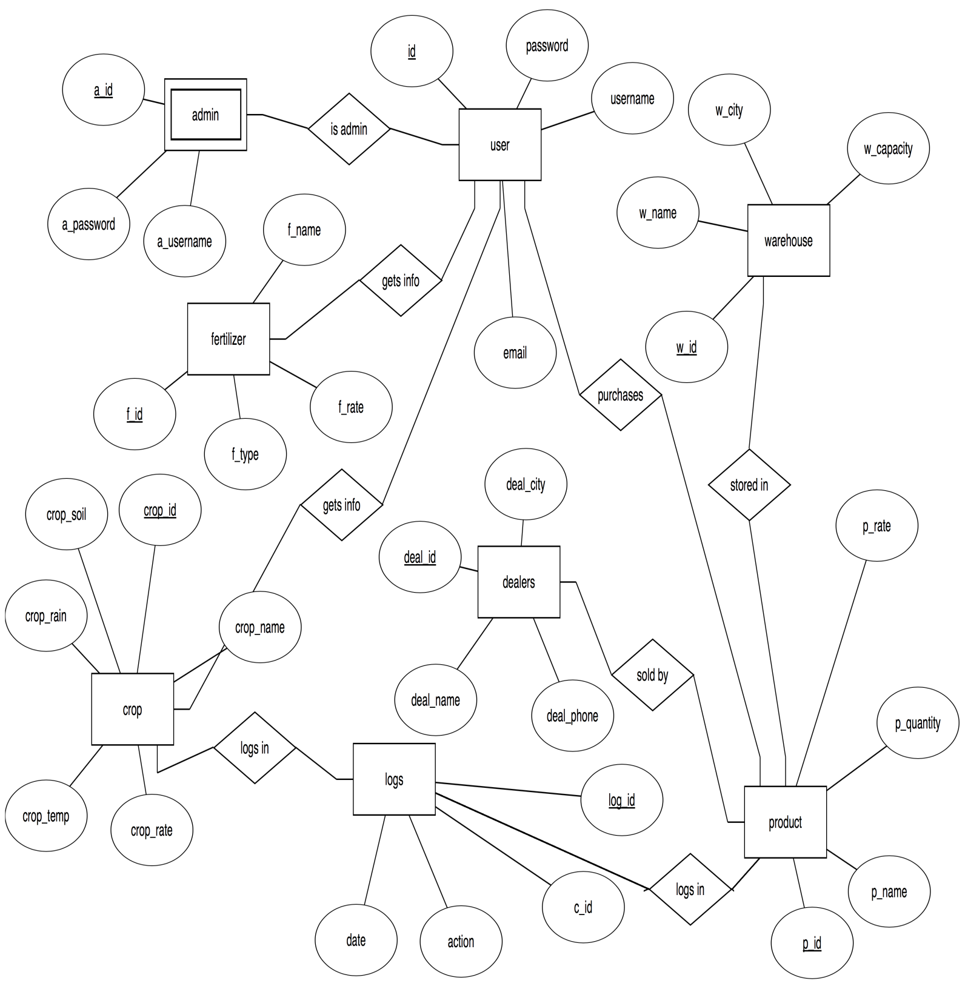

**Fig 4.1 ER Diagram**

**4.4 Relational ­Schema**

A relational schema shows references among fields in the database. When a primary key is referenced in another table in the database, it is called a foreign key. This is denoted by an arrow with the head pointing to the referenced key attribute.

A schema diagram helps organize values in the database. It also gives an idea of what order the tables should be created in. The fig. 4.2 shows the schema diagram for the database.

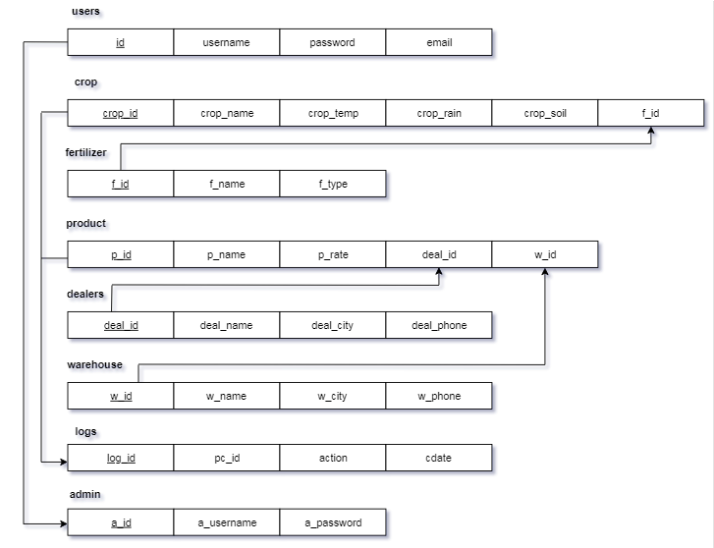

**Fig 4.2 Schema Diagram**

**4.5 Normalization**

Normalization is a systematic approach of decomposing tables to eliminate data redundancy (repetition) and undesirable characteristics like Insertion, Update and Deletion Anomalies. It is a multi-step process that puts data into tabular form, removing duplicated data from the relation tables. The fig. 4.3 shows the Normalized tables for the database.

* **Normalized Tables**

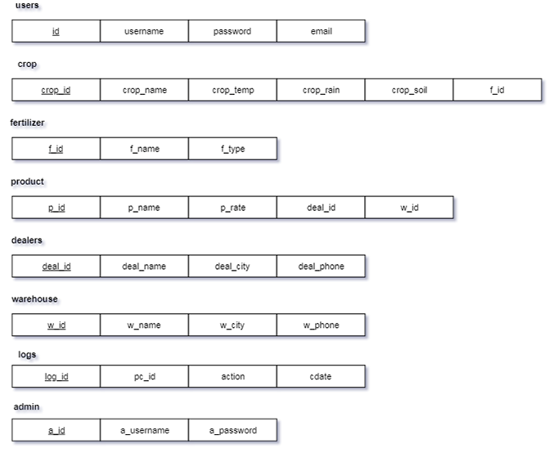

**Fig 4.3 Normalized Tables**

**Chapter 5**

**Implementation**

**5.1 Technologies/Frameworks used in building the project**

1. **HTML5**

HTML 5 is a mark-up language used for structuring and presenting content on the World Wide Web. It is the fifth and current major version of the HTML standard. HTML5 includes detail processing models to encourage more interoperable implementations, it extends, improves and rationalises the mark-up available for documents and introduces mark-up and application programming interfaces (APIs) for Complex Web applications. For the same reasons, HTML5 is also a candidate for Cross platform mobile applications because it includes features design with low power devices in mind.

1. **PHP**

PHP is the server side scripting language designed primarily for web development but also used as a general purpose programming language

PHP code may be embedded into HTML and HTML5 mark-up, or it can be used in combination with various web template systems, web content management systems and web Framework.

1. **SQL (Structured Query Language)**

MySQL Database Management System is used to store the user and product information which is stored in the secondary storage device and can be altered anytime. Normalized and efficient schema is used to avoid redundancy and inconsistency. The data is updated in real time.

1. **CSS**

Cascading Style Sheets (CSS) is a style sheet language used for describing the presentation of a document written in a mark-up language like HTML5.

**5.2 Code Snippets**

**5.2.1 Create table commands**

1. **USERS**

CREATE TABLE `users` (

`id` int(11) NOT NULL AUTO_INCREMENT,

`username` varchar(25) NOT NULL,

`password` varchar(25) NOT NULL,

`email` varchar(50) NOT NULL,

PRIMARY KEY (`id`)

) ENGINE=InnoDB AUTO_INCREMENT=13 DEFAULT CHARSET=latin1;

1. **CROP**

CREATE TABLE `crop` (

`crop_id` int(11) NOT NULL AUTO_INCREMENT,

`crop_name` varchar(25) NOT NULL,

`crop_temp` varchar(50) DEFAULT NULL,

`crop_rain` varchar(50) DEFAULT NULL,

`crop_soil` varchar(60) DEFAULT NULL,

`f_id` int(11) NOT NULL,

PRIMARY KEY (`crop_id`),

KEY `crop_name` (`crop_name`),

KEY `f_id` (`f_id`),

CONSTRAINT `crop_ibfk_1` FOREIGN KEY (`f_id`) REFERENCES `fertilizer` (`f_id`) ON DELETE CASCADE ON UPDATE CASCADE

) ENGINE=InnoDB AUTO_INCREMENT=14 DEFAULT CHARSET=latin1;

1. **FERTILIZER**

CREATE TABLE `fertilizer` (

`f_id` int(11) NOT NULL AUTO_INCREMENT,

`f_name` varchar(50) NOT NULL,

`f_type` varchar(50) NOT NULL,

PRIMARY KEY (`f_id`),

KEY `f_name` (`f_name`)

) ENGINE=InnoDB AUTO_INCREMENT=18 DEFAULT CHARSET=latin1;

1. **PRODUCT**

CREATE TABLE `product` (

`p_id` int(11) NOT NULL AUTO_INCREMENT,

`p_name` varchar(50) NOT NULL,

`p_rate` int(11) NOT NULL,

`deal_id` int(11) NOT NULL,

`w_id` int(11) NOT NULL,

PRIMARY KEY (`p_id`),

KEY `w_id` (`w_id`),

KEY `product_ibfk_1` (`deal_id`),

CONSTRAINT `product_ibfk_1` FOREIGN KEY (`deal_id`) REFERENCES `dealers` (`deal_id`),

CONSTRAINT `product_ibfk_2` FOREIGN KEY (`w_id`) REFERENCES `warehouse` (`w_id`)

) ENGINE=InnoDB AUTO_INCREMENT=9 DEFAULT CHARSET=latin1;

1. **DEALERS**

CREATE TABLE `dealers` (

`deal_id` int(11) NOT NULL AUTO_INCREMENT,

`deal_name` varchar(25) NOT NULL,

`deal_city` varchar(25) NOT NULL,

`deal_phone` bigint(15) NOT NULL,

PRIMARY KEY (`deal_id`),

KEY `deal_name` (`deal_name`)

) ENGINE=InnoDB AUTO_INCREMENT=9 DEFAULT CHARSET=latin1;

1. **WAREHOUSE**

CREATE TABLE `warehouse` (

`w_id` int(11) NOT NULL AUTO_INCREMENT,

`w_name` varchar(50) NOT NULL,

`w_city` varchar(50) NOT NULL,

`w_phone` bigint(20) NOT NULL,

PRIMARY KEY (`w_id`)

) ENGINE=InnoDB AUTO_INCREMENT=8 DEFAULT CHARSET=latin1;

1. **LOGS**

CREATE TABLE `logs` (

`log_id` int(11) NOT NULL AUTO_INCREMENT,

`pc_id` int(11) NOT NULL,

`action` varchar(50) NOT NULL,

`cdate` datetime NOT NULL,

PRIMARY KEY (`log_id`)

) ENGINE=InnoDB AUTO_INCREMENT=35 DEFAULT CHARSET=latin1;

1. **ADMIN**

CREATE TABLE `admin` (

`a_id` int(11) NOT NULL AUTO_INCREMENT,

`a_username` varchar(25) NOT NULL,

`a_password` varchar(25) NOT NULL,

PRIMARY KEY (`a_id`),

CONSTRAINT `admin_ibfk_1` FOREIGN KEY (`a_id`) REFERENCES `users` (`id`)

) ENGINE=InnoDB AUTO_INCREMENT=3 DEFAULT CHARSET=latin1;

**5.2.2 Config- To establish connection**

This is a code snippet to show how PHP is used to connect to the local MySQL database using the localhost server.

* Start session by creating php variables to hold hostname,username and password
* Using “mysqli_connect” we establish connection with php variables as parameters

<?php

session_start();

$host="localhost";

$user="root";

$password="";

$db="farmer";

$con=mysqli_connect($host,$user,$password,$db);

?>

**5.2.3 The Login and Sign Up pages**

**Login page validation snippet**

1. Login fields are filled and “Submit” is clicked data is redirected to “login.php”
2. “mysqli_query($con,$q)” is executed to store login credentials into result.
3. Login fields are checked with the one in database using :
4. “mysqli_fetch_assoc($query1)” and direct page to ”home.php” if true else display “Please check username/password”.

<?PHP

if(isset($_POST['username']))

{ $uname=$_POST['username']; $password=$_POST['password'];

$sql="select * from users where username='".$uname."'AND password='".$password."' limit 1";

$result=mysqli_query($con,$sql);

if(mysqli_num_rows($result)==1)

{ $_SESSION["username"] = $uname;

$query1=mysqli_query($con,"select email,username,password from users where username ='".$_SESSION["username"]."' ");

{ $row=mysqli_fetch_assoc($query1);

$_SESSION["email"] = $row["email"];

$_SESSION["username"] = $row["username"];

$_SESSION["password"] = $row["password"];

}

echo "<script> window.location.assign('home.php'); </script>";

exit();

}else

{echo '<script>alert("Please check username/password")</script>';

echo '<script>window.location="login.php"</script>';

exit(); }

}?>

**Sign Up page snippet (Insert into DB)**

1. The user fills the fields and the data is posted onto php variables
2. Using “INSERT INTO users VALUES(‘&username’,’&password’,’&email’)” the details is inserted into the database by the registration.php page.
3. It redirects back to login.php once the user account is created.
4. If the username is taken, “Username already taken” alert is displayed.

<?PHP

if(isset($_POST['submit']))

{

$username = $_POST['username'];$password = $_POST['password'];$email=$_POST['email'];

$q = " select username from users where username='$username'";

$result = mysqli_query($con, $q);

$num = mysqli_num_rows($result);

if($num!=0)

{echo '<script>alert("Username already taken")</script>';

echo '<script>window.location="registration.php"</script>';}

else{$qy= " insert into users(username , password, email) values ('$username' , '$password' , '$email') ";

mysqli_query($con, $qy);

header('location:login.php');

}

}

?>

**5.2.4 Triggers**

The “NOW( )” is fetched when the admininserts/deletes a product using the Insert Product form/Delete Product form from the database and is stored in the logs table, using Triggers. “NOW()” returns the system time and date.

CREATE TRIGGER `insertproduct` AFTER INSERT ON `product`

FOR EACH ROW insert into logs values(null, NEW.p_id,'product inserted',NOW())

CREATE TRIGGER `deleteproduct` AFTER DELETE ON `product`

FOR EACH ROW insert into logs values(null, OLD.p_id,'product deleted',NOW())

**5.2.5 Stored procedure**

1. This procedure is used delete a crop from the crop table.

DELIMITER $$

CREATE DEFINER=`root`@`localhost` PROCEDURE `deletecropproc`(IN `c_id` INT)

NO SQL

delete from crop where crop_id=c_id$$

DELIMITER ;

1. This procedure is used to display the crop details.

DELIMITER $$

CREATE DEFINER=`root`@`localhost` PROCEDURE `displaycrop`()

    NO SQL

SELECT crop_name,crop_temp,crop_rain,crop_soil,f_name from crop c, fertilizer f where c.f_id=f.f_id$$

DELIMITER ;

**Chapter 6**

**TESTING AND RESULT**

This chapter gives the outline of all testing methods that are carried out to get a bug free system. It provides a way to check the functionality of components sub-assemblies and/or a finished product. It is the process of exercising software with the intent of ensuring that the Software system meets its requirements and user expectations and does not fail in an unacceptable manner. There are various types of test. Each test type addresses a specific testing requirement.

**6.1 TESTING PROCESS**

Testing is an integral part of software development. Testing process certifies whether the product that is developed compiles with the standards that it was designed to. Testing process involves building of test cases against which the product has to be tested.

**6.2 TESTING OBJECTIVES**

The main objectives of testing process are as follows.

1. Testing is a process of executing a program with the intent of finding an error.

2. A good test case is one that has high probability of finding undiscovered error.

**6.3 TEST CASES**

|  |  |  |  |  |
| --- | --- | --- | --- | --- |
| **SL NO** | **TEST RESULTS** | **EXPECTED RESULTS** | **OBSERVED**  **RESULTS** | **REMARKS** |
| 1 | Insert a Record | New tuple should be inserted | Query OK 1 row affected or inserted | PASS |
| 2 | Insert a Record | Ttuple should be inserted | ERROR | FAIL |
| 3 | Search a Record | Display the Record | Required Record | TRUE |
| 4 | Create trigger | Trigger Created | Query OK Trigger created | PASS |
| 5 | Create Stored  Procedures | Stored Procedures  Created | Query OK  Procedures Created | PASS |
| 6 | Delete a record | Tuple removed from database | Query OK record deleted | PASS |

**6.4 SNAPSHOTS**

1. **Login Page**

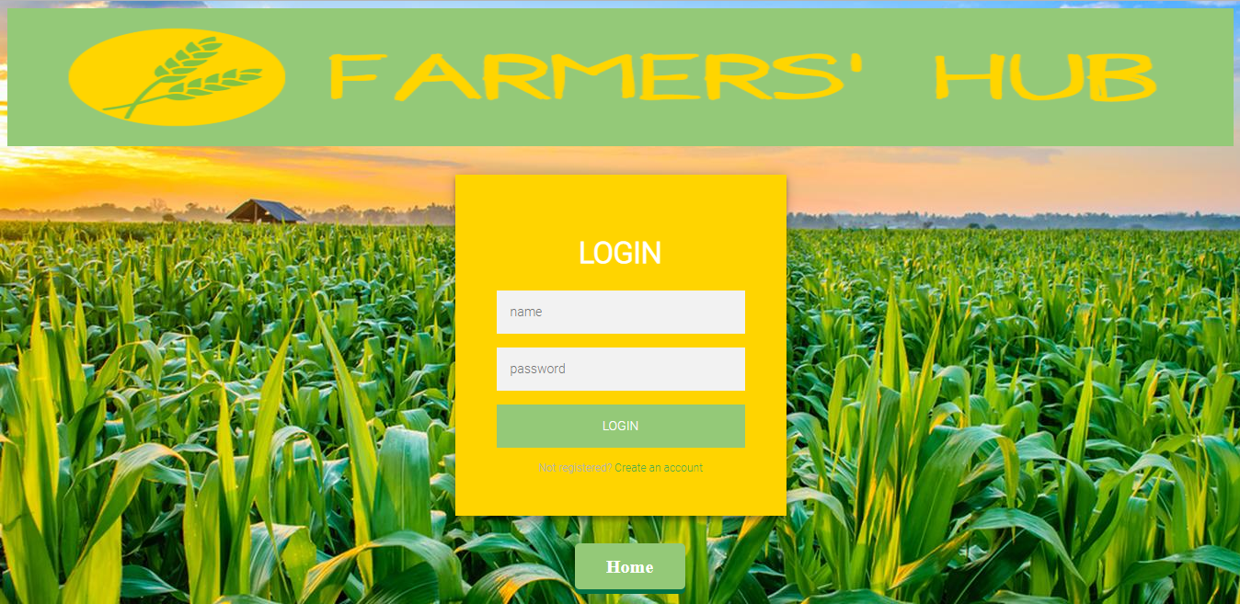

**Fig 6.1 Login Page**

The fig 6.1 is the login page through which the user can login into the website by giving the necessary credentials.

1. **Signup Page**

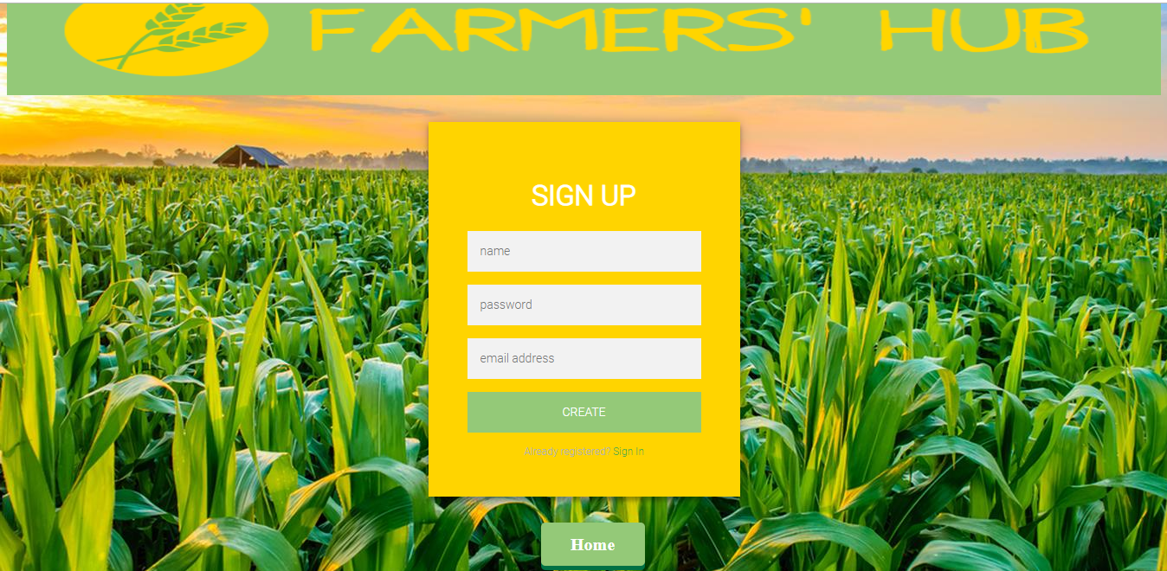

**Fig 6.2 Signup Page**

The fig 6.2 is the signup page through which the user can register into the website by giving the necessary credentials and once done he/she is redirected back to login page.

1. **Home Page**



**Fig 6.3 Home Page**

The fig 6.3 is the home page, once logged in, the user can either access information or buy various products.

1. **Get Info Page**



**Fig 6.4 Get Info Page**

The fig 6.4 is the get info page. The user can access information about the various crops and fertilizers. The user can additionally access information about the dealers and warehouse.

The fig 6.5 shows the crop details page, similarly the fertilizer, dealers and warehouse details are displayed.

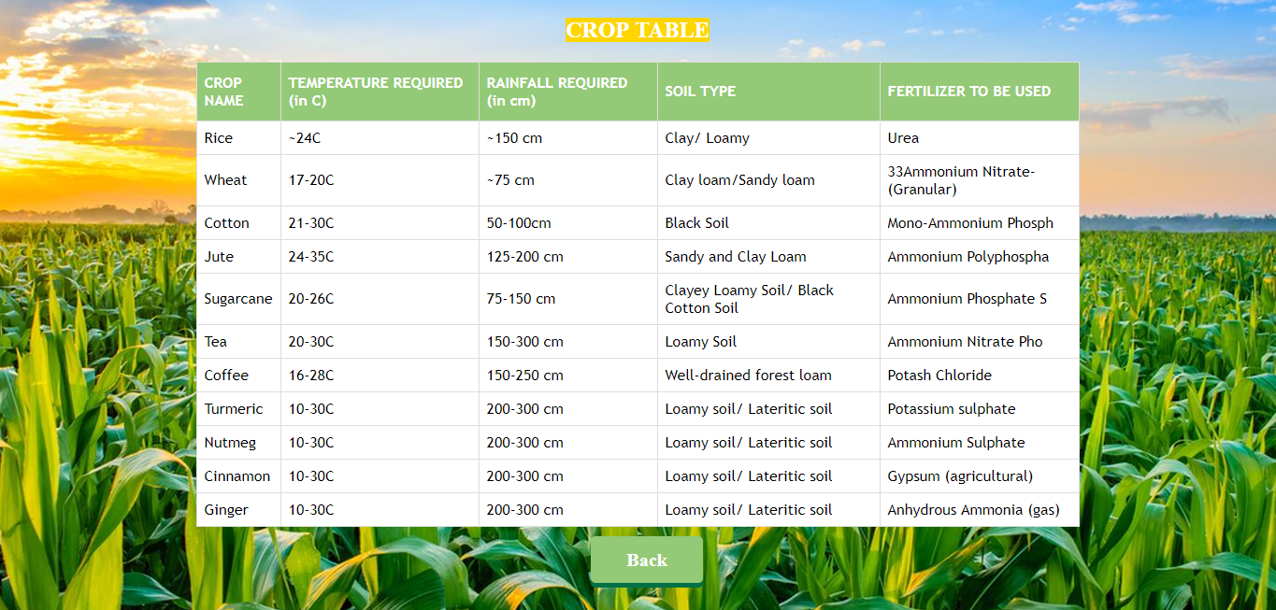

**Fig 6.5 Crop Details Page**

1. **Buy Page**

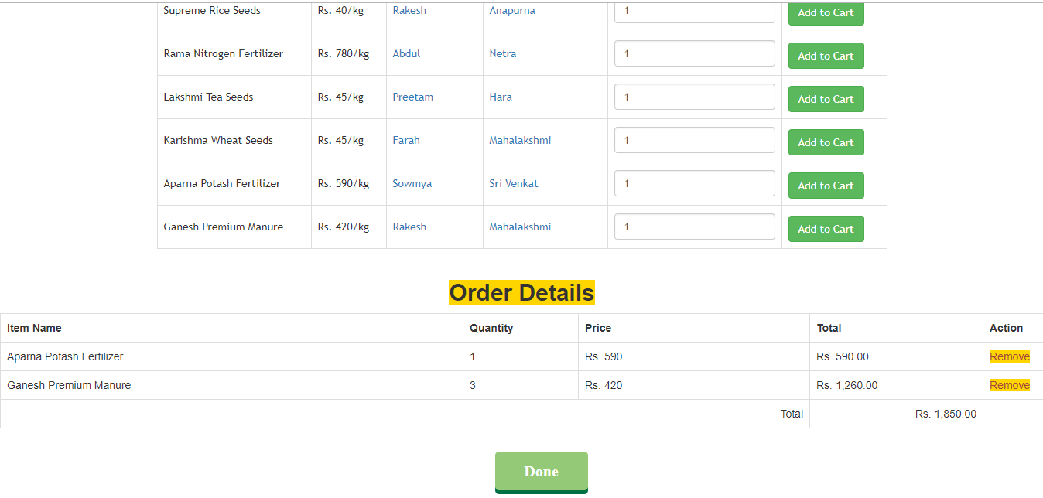

**Fig 6.6 Buy Page**

The fig 6.4 is the buy page. The user can buy the various products available. Add to Cart allows user to add different products into the cart. User can add increase the quantity of the product he/she wants to purchase through the Quantity option. Once a product has been added it can be removed by simply clicking on the Remove button. Once the user has purchased everything required, a bill is generated which contains the total amount of the purchase. After the bill is viewed by the user, he/she can click on Done and their order is successfully placed and redirects them back to the home page.

1. **Admin Login Page**

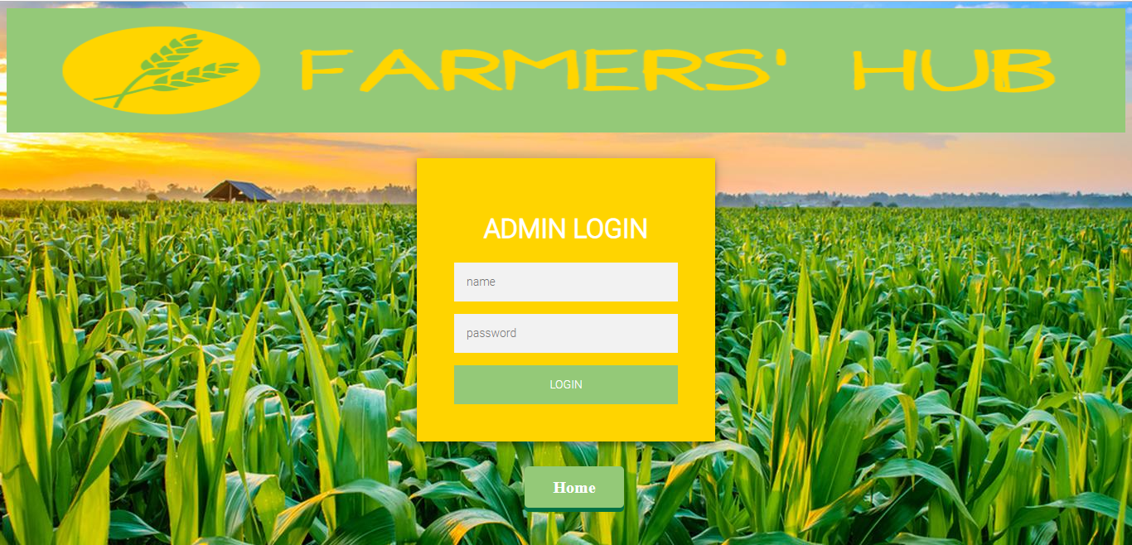

**Fig 6.7 Admin Login Page**

The fig 6.7 is the login page through which the admin can login into the website by giving the necessary credentials.

1. **Admin Home Page**

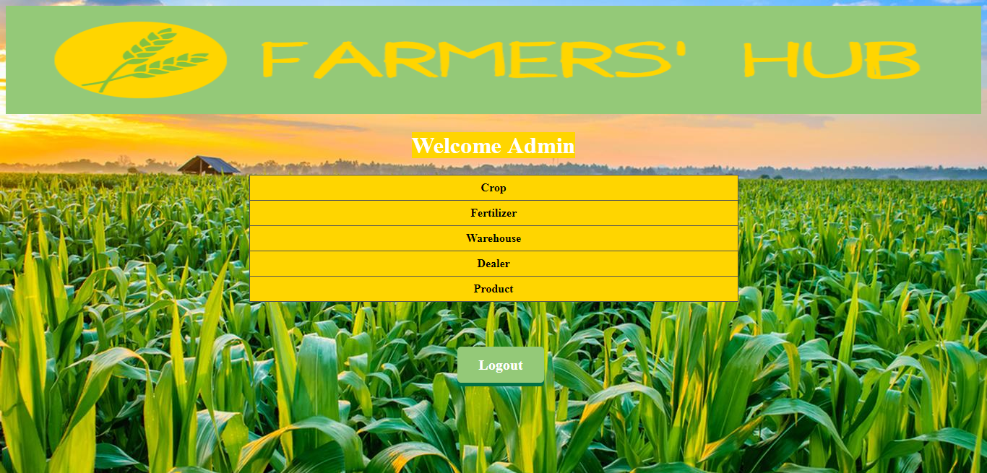

**Fig 6.8 Admin Home Page**

The fig 6.8 is the admin home page. The admin can insert/delete various crops, fertilizers, warehouses, dealers, and products. The fig 6.7 shows the Admin Product Page, through which the admin can add a new product, delete an existing product or update the price of an existing product. Similarlythe Admin Crop page, Admin Fertilizer page, Admin Dealers Page, Admin Warehouse Page is implemented.

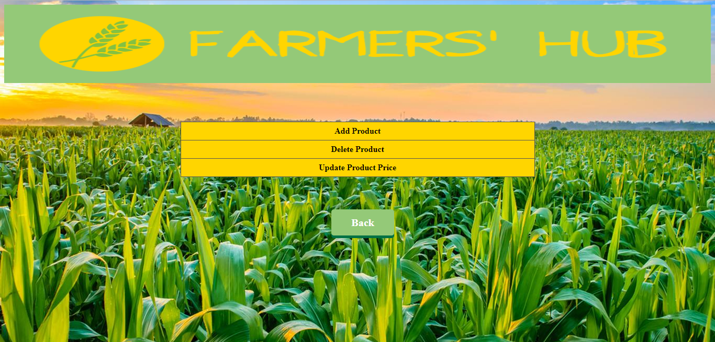

**Fig 6.9 Admin Product Page**

The fig 6.10 shows the Insert Product/Delete Product/Update Product forms through which the admin is able to insert a product, delete a product and update product price which is successfully reflected in the database.

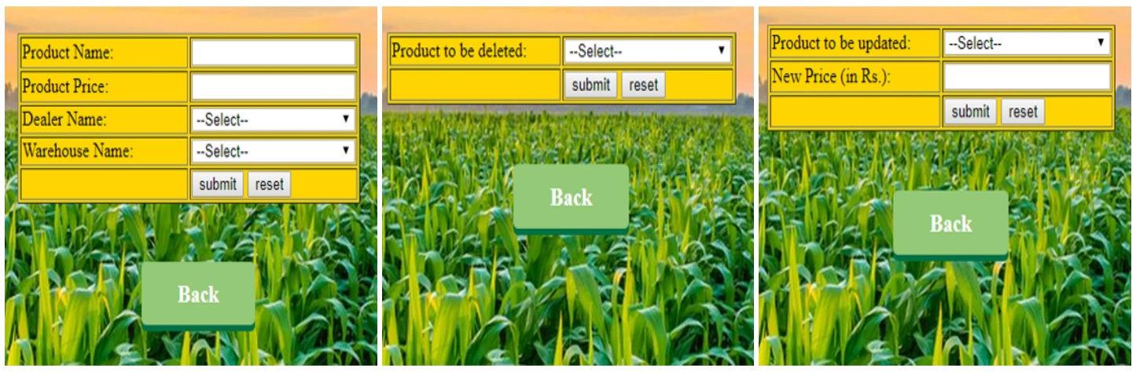

**Fig 6.10 Forms used by Admin**

**CONCLUSION**

The design of the Farmer Database Management System is done by taking into consideration all the needs of the agricultural sector. The intention of this whole system is to bridge the gap between the IT sector and the agricultural sector. This has been done so by creating a one-stop portal for farmers to retrieve information and also to buy various farming related products with the simple click of a button. This application has been successfully tested with suitable test cases. It is user friendly and contains suitable options for users. This is developed using web languages such as HTML, CSS, JAVASCRIPT and PHP for writing logic and page design. MySQL is used to manage the database. The goals achieved by this project are:

* + Global access.
  + User friendly environment.
  + Efficient management of records.
  + Simplification of operations.

**REFERENCES**

1. PHP reference (<https://www.w3schools.com/php/>).
2. Fundamental of Database Systems by Ramez Elmasri 7th Edition.2017.
3. Database Systems by Ramakrishnan 3rd Edition,2003.
4. PHP official Documentation (<http://php.net/manual/en>).
5. Sql Quick Reference (<http://www.w3schools.com/sql/sql-quickref.asp>).